**Helping Hands**

Deliverable 4

5/9/2019

Anusha Malla

Briana Jenkins

Daniel Bae

Haythem Abdelkhalek

Trmnit Tesfatsion

Wonjin (James) Choi

IS 436 - Structured Systems Analysis and Design

# **ERD:**

# 

# 

# 

# 

# **ERD Descriptions:**

**Entities:**

* **1nd Entity** = “Tutor”: is the record of the tutor
  + Includes tutor_name, tutor_email, tutor_courses, tutor_availability and tutoring_id (primary key)
* **2rd Entity** = “Tutoring_Room”: this records the room information of where the tutoring is going to happen
  + It includes room_location, room_number, room_capacity and room_id (primary key).
* **3th Entity** = “Supervisor”: records about the information of the supervisor of the tutoring center.
  + It includes a primary key of supervisor_id, and attributes such as supervisor_name, supervisor_emial, asupervisor_department.
  + It has also a foreign key from the Tutoring_Room entity called Room_ID
* **4th Entity** = “Student”: records information about student
  + Includes student_name, student_email, student_course and a primary key called student_id
* **5st Entity** = “Session”: records about a session that is booked.
  + It has four primary keys session_id, student_id, tutor_id, and room_id
  + student_id, tutor_id, and room_id also acts as a foreign key from the tutor, studnet, and tutoring_room tables.

**Relationships:**

* The events involves only one account. Whereas, the account incorporates that there can be a zero-to- many events accessible to it.
* Tutor: can have 0 or more sessions booked, while a session must have a tutor booked for it.
* Tutor: can have 1 or more supervisors, while a supervisor can have one or more tutors he/she manages
* Supervisor: can book 0 or more tutoring rooms, whereas a tutoring room can be booked by one or more supervisors
* Supervisor: can manage 0 or more students, whereas a student can have one or more supervisors.

-Student: can book a session 0 or multiple times, while a scissor must have one

have one student to be booked.

-Session: must have a student, a tutor, and a designated tutoring_room to be able to booked.

-Tutoring_room can have 0 or multiple booked sessions.

**Briana’s Alternative Matrix:**

# 

**Final Result:**

Alternative 1: 390 points

Alternative 2: 370 points

**Alternative 3: 550 points**

**Timnit’s Alternative Matrix:**

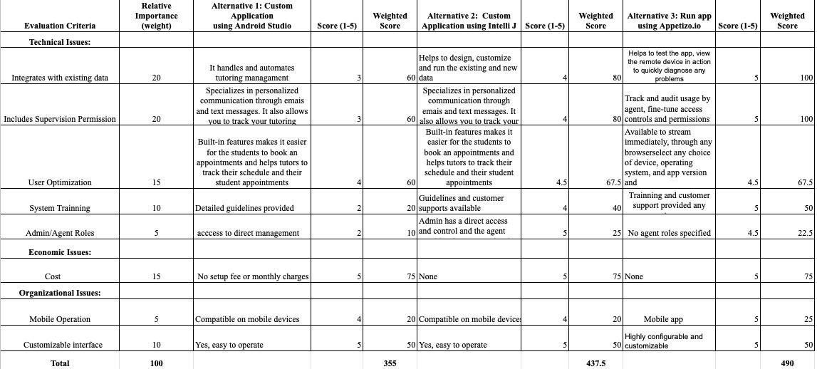

**Final result:**

Alternative 1: 355 points

Alternative 2: 437.5 points

**Alternative 3: 490 points**

**Anusha’s Alternative Matrix:**

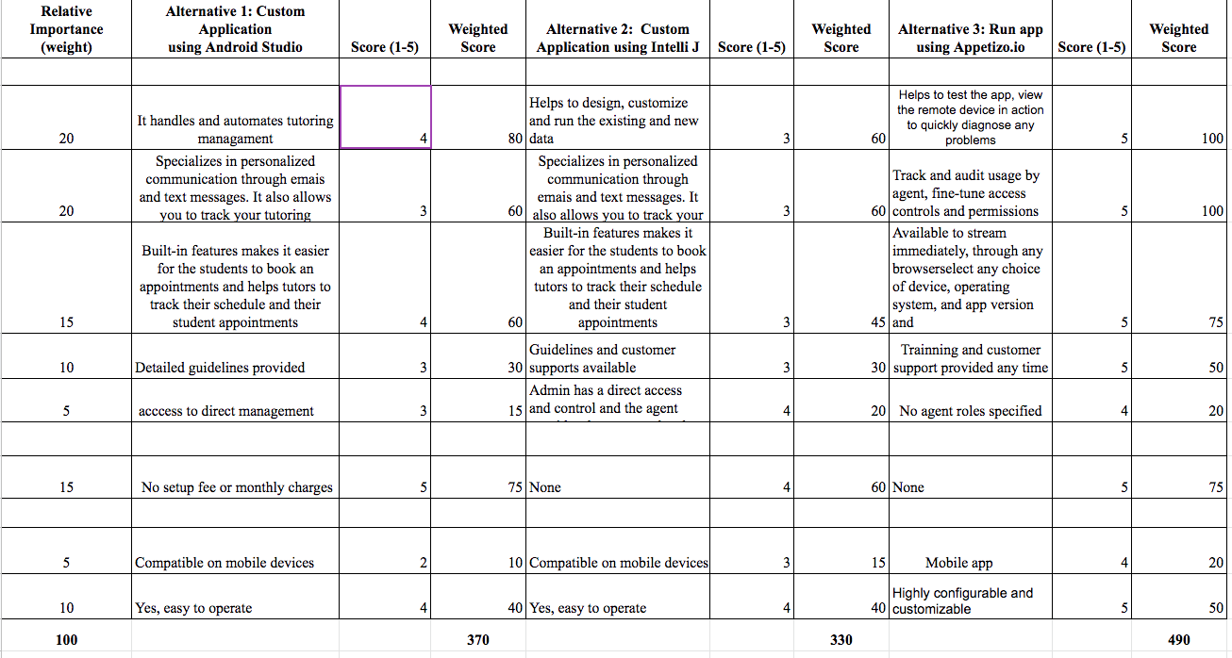

**Final result:**

Alternative 1: 370 points

Alternative 2: 330 points

**Alternative 3: 490 points**

**Haythem’s Alternative Matrix:**

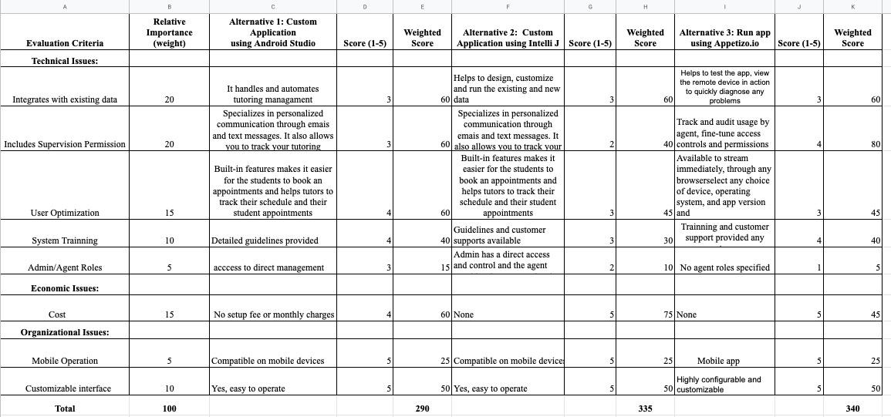

**Final result:**

Alternative 1: 290 points

Alternative 2: 335 points

**Alternative 3: 340 points**

**Daniel’s Alternative Matrix:**

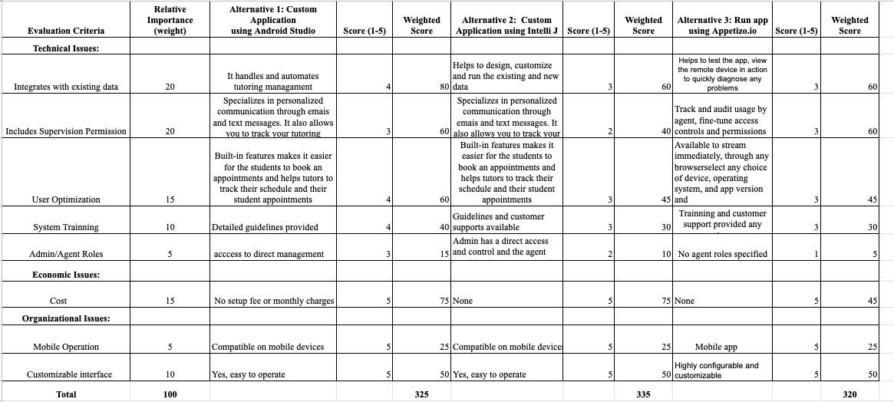

**Final result:**

Alternative 1: 325 points

Alternative 2: 335 points

Alternative 3: 320 points

**James Alternative Matrix:**

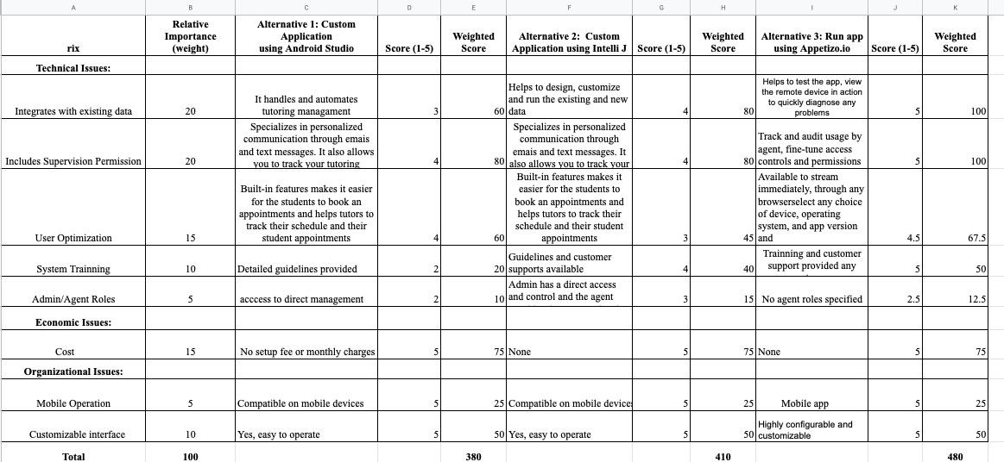

**Final Result:**

Alternative 1: 380 points

Alternative 2: 410 points

**Alternative 3: 480 points**

**Team’ Alternative Matrix:**

*(For more clarity of pic look at attachment: Alternative Matrix _D4)*

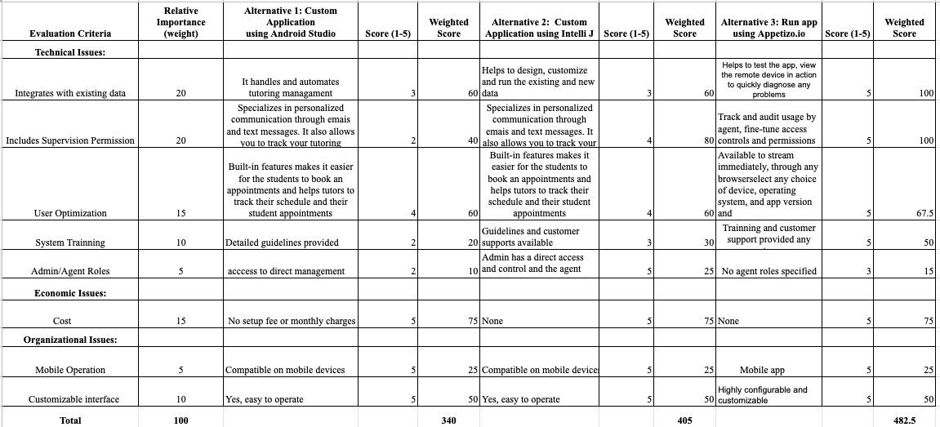

**Final Result:**

Alternative 1: 340 points

Alternative 2: 405 points

**Alternative 3: 482.5 points**

# 

# **Team Matrix Description:**

After reviewing all of the team choices based off of the original team matrix, our team has landed on the highest ranking alternative. Almost every group member voted on alternative 3 being appetizo.io . The biggest reasons why alternative 3 got the higher points were because of system training and tracks the usage. The application will give system training to the tutors,supervisors and the students. It’ll also give more trackage to the users so the supervisors can generate detailed reports. Each member agreed on which alternative was the best of the three which ended up being the first alternative. Running out Helping Hands’ app through the Appetizio.io software meets all our teams need. We came to this conclusion based on the needs of our app and our potential future customers. Appetizio.io can diagnose any problems our app encounters. Also, it is highly configurable and customizable making it very easy for first timers to familiarize themselves in a short amount of time. It can be also used remotely to diagnose any problems that are seen in out app. Most importantly, it can be used by any device based on the customers choice, operating system making it very efficient and it doesn't cost money. Thus, making it more affordable.

**Architecture Matrix:**

|  |  |  |  |  |
| --- | --- | --- | --- | --- |
| **Requirements** | **Server-Based** | **Client-Based** | **Thin Client-Server** | **Thick Client-Server** |
| **Operational Requirements** |  |  |  |  |
| System Integration Requirements |  |  | X |  |
| Portability Requirements | X |  |  |  |
| **Performance Requirements** |  |  |  |  |
| Speed Requirements |  |  | X |  |
| Availability/Reliability Requirements | X |  | X | X |
| **Security Requirements** |  |  |  |  |
| Access Control Requirements | X |  |  |  |
| **Cultural/Political Requirements** |  |  |  |  |
| Explicit Unstated Norms |  |  | X |  |
| Legal Requirements | X |  |  |  |

# **Architecture Matrix Description**

Based on our architecture matrix, we have determined which architecture will be the best fit. In this particular case, server-based architecture is a good fit for the type of internal system we are trying to build.

System Integration requirements will able to import and export data such as excel so the supervisor can generate reports in a easier way. The system will allow the supervisor to read and write appointments, as well as the database. Speed requirement is needed because our requirements stated that the system must update every 15 minutes. Availability and reliability requirements are checked because we need the app to function at all times. Access control because we only want the supervisor to use change certain features. Tutors can change their own schedule as well as the students.This will allow the supervisor to hand out punishments for student making no shows. Unstated Norms explicit will be used because our primary goal is to use it in North America as of the moment. We will be using date fields specifically such as date month and year in that order. Legal requirement is needed because

Our app is going to be used for tutoring purpose in a University, and it is important we must follow legal requirements for IT systems and be knowledgeable of any UMBC restrictions and legalities.

# Hardware/Software Specification

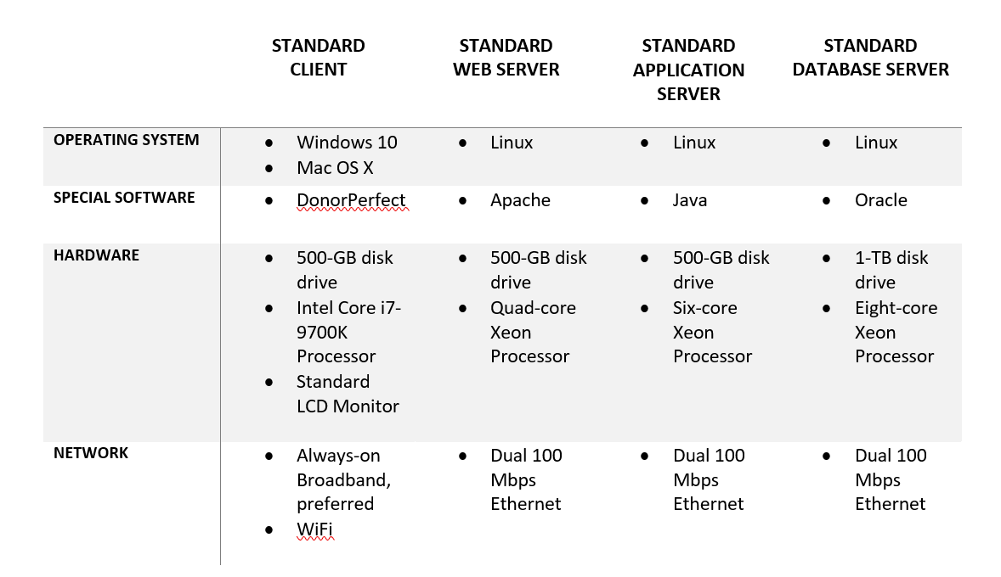

**KanbanFlow:**

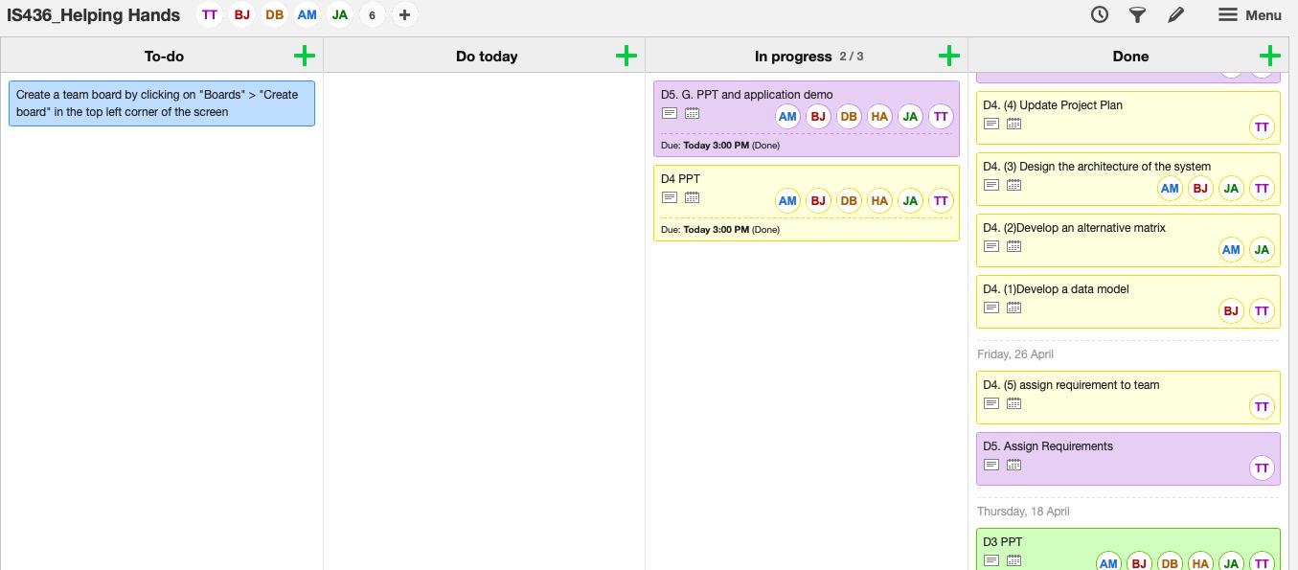

**Updated Gantt chart:**

*(look for attachment:D4-Gantt chart_Helping Hands)*

